Activity 1: Deconstruct Sources
Using the illustrations below answer the questions provided
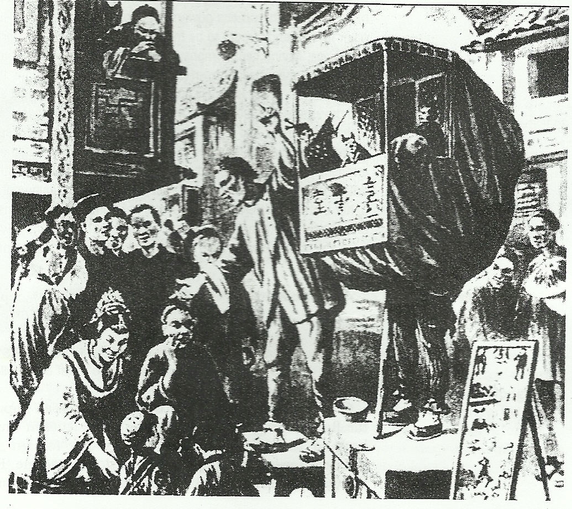
Source: An illustration by a European correspondent of a glove-puppet show performed by Boxers to encourage recruiting.
Q1. What does this image tell you?
___________________________________________________________________________
___________________________________________________________________________
___________________________________________________________________________
___________________________________________________________________________
Q2. Why do you think this illustration was drawn?
___________________________________________________________________________
___________________________________________________________________________
___________________________________________________________________________
___________________________________________________________________________
Q3. What evidence in the illustration helps you know why it was drawn?
___________________________________________________________________________
___________________________________________________________________________
___________________________________________________________________________
___________________________________________________________________________
Q4. Write a question to the author that is left unanswered by the illustration
___________________________________________________________________________
___________________________________________________________________________
___________________________________________________________________________
___________________________________________________________________________

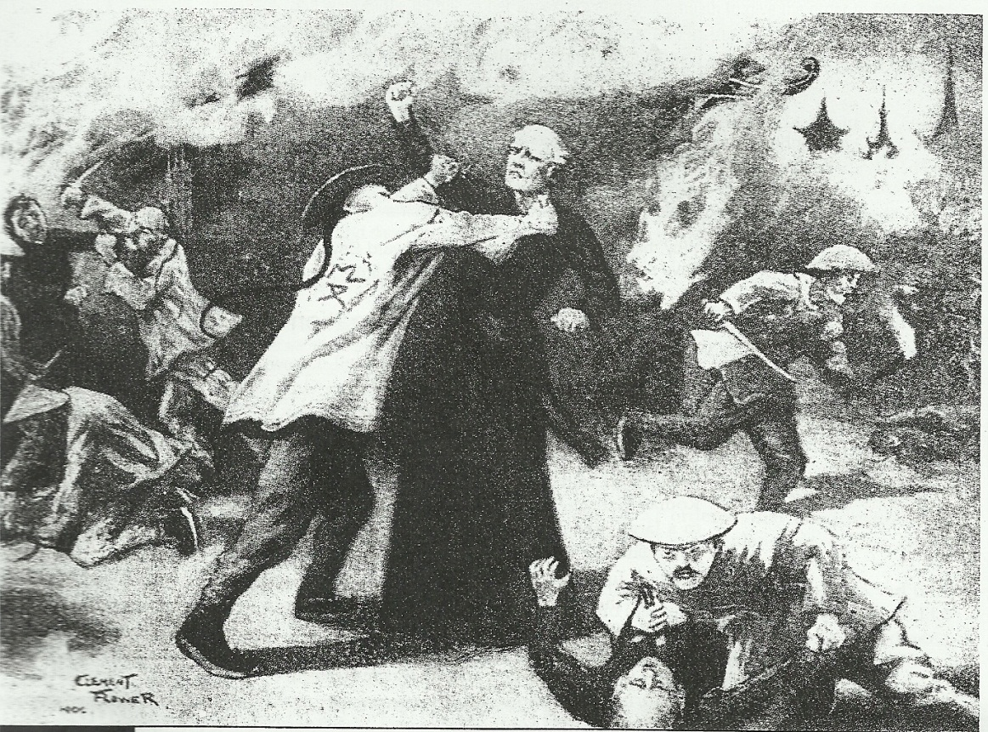
Source: A painting by a European artist in 1900 showing a Western view of the Boxers in action
Q1. What does this image tell you?
___________________________________________________________________________
___________________________________________________________________________
___________________________________________________________________________
___________________________________________________________________________
Q2. What questions does this illustration raise in your mind?
___________________________________________________________________________
___________________________________________________________________________
___________________________________________________________________________
___________________________________________________________________________
Q3. What features of the illustration indicate that it gives a Western point of view? ___________________________________________________________________________
___________________________________________________________________________
___________________________________________________________________________
___________________________________________________________________________

